

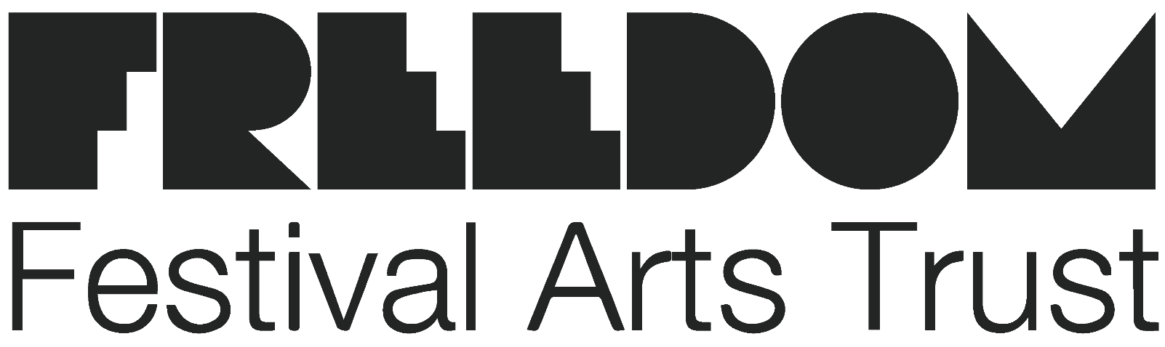
1

Visiting our office
Freedom Festival’s office is located off High Street in Hull’s Old Town.

Our full address is:

Suite 9, Bond 31, 42/43 High Street, Hull, HU1 1PS

To reach us by car the nearest car parking is:

High Street Car Park
This is approximately 3 minutes from our building.

King William House APCOA
This is approximately 5 minutes from our building.

Nearby bus stops are:

North Bridge Stop Carr Lane Stop
The nearest train station is:

Hull Paragon Interchange followed by:
Number 13 bus towards Bilton Grange, exit at White Hart (4 minute walk to the office)

Or 16 minute walk from the station to our office

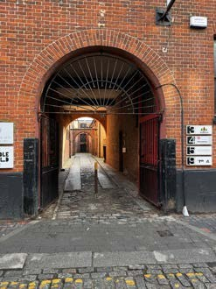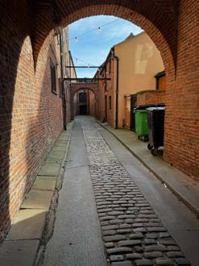

Building entrance

Please note the pavement outside our building is on an uneven, cobbled road with 8-14cm kerbs. The closest drop kerb is at the arched entrance to Bond 31.

There is no permanent ramp access to our building, but please contact the person who organised your meeting in advance of your visit and we will be able to arrange one.

Once inside our building all of the ground floor has step free access and a dedicated accessible toilet.

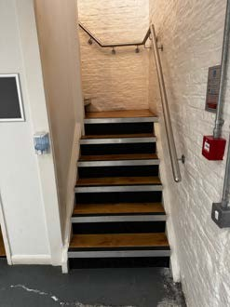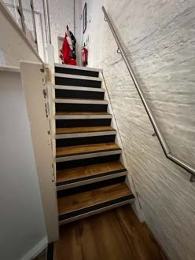

Main office

To reach our main office there are 15 steps on our staircase and no lift access.

We are always happy to arrange an alternative venue for our meeting. Please do let us know by contacting the person who organised your meeting if you have any access requirements you’d like us to be aware of.

